Lab: Knowledge Graphs
Submitted by: Ardra Suresh
Reshma Mani

1. Modeling KG with Triples using RDF & RDFS
1.1) Get familiar with the RDF and RDF(S)
1) What are the namespace references and URIs (i.e., the namespace prefixes) of the music dataset and schema?
beatles.ttl
PREFIX : <http://stardog.com/tutorial/>
PREFIX rdf: <http://www.w3.org/1999/02/22-rdf-syntax-ns#>
PREFIX xsd: http://www.w3.org/2001/XMLSchema#
music_schema.ttl
PREFIX : <http://stardog.com/tutorial/>
PREFIX rdf: <http://www.w3.org/1999/02/22-rdf-syntax-ns#>
PREFIX rdfs: <http://www.w3.org/2000/01/rdf-schema#>
PREFIX xsd: http://www.w3.org/2001/XMLSchema#

2) Draw the directed labelled graph of the triples in the “beatles.ttl”, where subjects and URI-identified objects are represented as nodes (ellipses), literal objects are represented as nodes (boxes), and predicates are labeled edges in the graph.

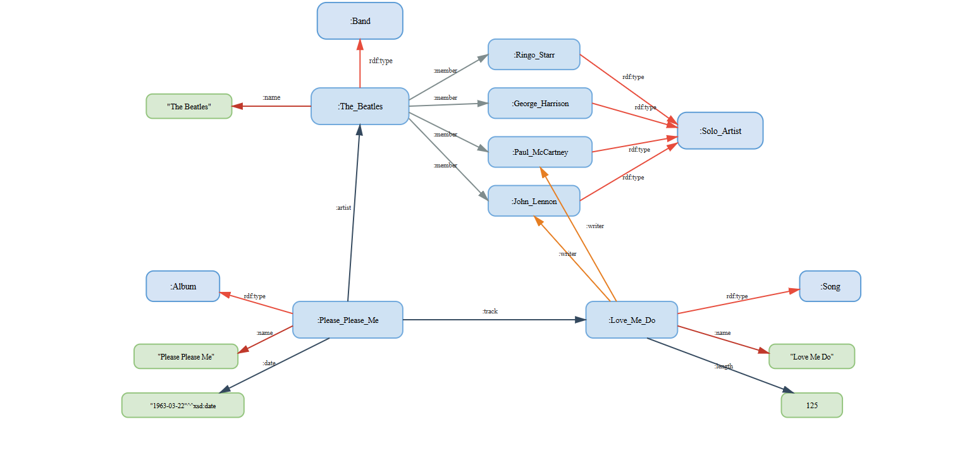

1.2 Understand the RDF triples in Open Linked Data
1) Which ontology is used in this dataset to describe the data?

The YAGO page for The Beatles uses multiple standardized ontologies to describe the data. The main ontologies used are:
YAGO Ontology

- Namespace prefix: yago:

- Base URI: http://yago-knowledge.org/resource/

- Used for: YAGO classes, individuals, and properties.

RDF & RDFS Ontology Vocabulary

- rdf: → http://www.w3.org/1999/02/22-rdf-syntax-ns#

- rdfs: → http://www.w3.org/2000/01/rdf-schema#

- Used for: basic structure such as rdf:type, rdfs:label.

OWL Ontology

- owl: → http://www.w3.org/2002/07/owl#

- Used for: equivalence, class definitions.

Schema.org Ontology

- schema: → http://schema.org/

- Used for: general properties like schema:genre, schema:member.

Wikidata Ontology

- wd: and wdt: (if shown)

- Base URI: http://www.wikidata.org/entity/

- Used for: linking YAGO entities to Wikidata items.

GeoNames (sometimes present depending on entity)

- For geographical information (not heavily used for The Beatles, may appear in other entities)

2. Choose three triples in https://yago-knowledge.org/resource/TheBeatles and write the information described by the triples in natural language text.
Triple 1:
- RDF: <http://yago-knowledge.org/resource/The_Beatles> rdfs:label "The Beatles" .
- Natural Language: The resource representing the band is labeled “The Beatles”.
Triple 2:
- RDF: <http://yago-knowledge.org/resource/The_Beatles> schema:genre <http://yago-knowledge.org/resource/Rock_music>
- Natural Language: The Beatles is associated with the Rock Music Genre
Triple 3:
- RDF: https://yago-knowledge.org/resource/TheBeatles <http://dbpedia.org/ontology/activeYearsStartYear>“1960”^^xsd:gYear
- Natural Language: The Beatles began their active years in 1960

